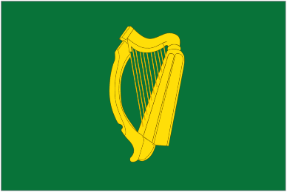**LB e-NEWS**

**Leinster Deaf Sports Council**

**February 2012**

Warm welcome to the first LB (Leinster Branch of Deaf Sports Ireland formerly Irish Deaf Sports Association) e-news. Leinster Deaf Sports Council (LDSC) is keen to touch base with its members and all others who are interested in Deaf sports. We hope that it will be first of many e-news.

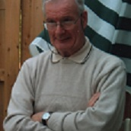**Tribute to Patrick O’Leary (1938 – 2011: Former Chairperson of LDSC)**

Patrick was born in James Street in Dublin. He was educated at St. Joseph’s, School for Deaf Boys, Cabra. After leaving school he worked as a tailor with Best Ltd. Later he became a baker and then a printer operator. Patrick was a man who loved a challenge and was fearless in his pursuit in organising events for the Deaf Community. He served on many committees including being Chairman of Leinster Branch of the IDSA (now DSI). Many deaf people view Patrick as a legend and they thank him for empowering them to speak up for themselves. He was a man of many talents and had given up a lot of his time to others. The large gathering at his funeral services was amazing and showed the high esteem many of them hold for Patrick. His wife, Josephine and children, Caroline, David and Kevin wish to everyone for their support during their loss. He is greatly missed. Rest in Peace Patrick.

**Patrick Power Jnr:** Patrick is one of the great deaf legends in Ireland. I knew him for a long time. I always enjoyed his conversations and deaf politics. We share the same principles, especially leftist views. Patrick was very good with the constitution of Dublin Deaf Association. I am privileged to have worked with him. He is joining my late father and late Christopher Foran, whom I call as three deaf musketeers.

**Niall McCormack:** Patrick has done a lot of great work for the Deaf community and empowered Deaf people. He was right to challenge over the planned move to Drumcondra from Rathmines. Looking back he proved to be right. We never forget that.

**Laurence Coogan:** We knew Patrick as a man with a big heart and endless charity. He always wanted to help people, no matter what problems they had; be it your car, TV, house jobs etc. The Deaf community and DSI gained much pleasure from his organising skills he done with such energy. We learned a lot from his will power. For this we thank God for Patrick’s life amongst us in the Deaf community.

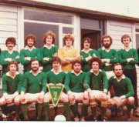**40th DSI Interprovincial Tournament**

Deaf Sports Ireland (DSI) 40th Interprovincial Tournament takes place in Westport, Co Mayo on 6th/7th April 2012, hosted by Connaught Deaf Sports Council (CDSC). DSI will hold its Annual General Meeting on 6th April at Castlecourt Hotel in Westport at 4pm. It will be followed by the exhibition and launch of new DSI logo.

The soccer and basketball teams will play the following day with the winning teams presented at the social event dance in Castlecourt Hotel that evening. It costs €30 with non-refundable deposit of €10 by 31st March. For more details, please contact connachtdeafsports@gmail.com. More details about the accommodation and travel can be found at LDSC new facebook page or email LDSC at leinsterdeaf@gmail.com

The first football tournament was in 1973 at Dublin when Leinster was the first winner. Leinster is the most winner of the tournament, winning 21 times. Basketball was added in 2002 with Leinster the most winning team taking the crown 8 times. Good luck to our Leinster teams on this year’s tournament.

**Current Update**

LDSC is planning a number of fundraising activities to develop its sporting programme in Leinster.

LDSC is reviewing its current constitution in consultation with Deaf Sports Ireland. Update will follow…

LDSC is restructuring its database membership. If you wish to renew membership or join as new member, please contact us at leinsterdeaf@gmail.com or by text at 0868191929

**New LDSC 2012 Committee**

Shane Keogh, Chairperson

Kevin Stanley, Secretary

Ivan Gryslov, Treasurer

Sarah Lyon,

Jason Grace

Laura Clarke

Vinny Gill

David Mulligan

Alan Smyth