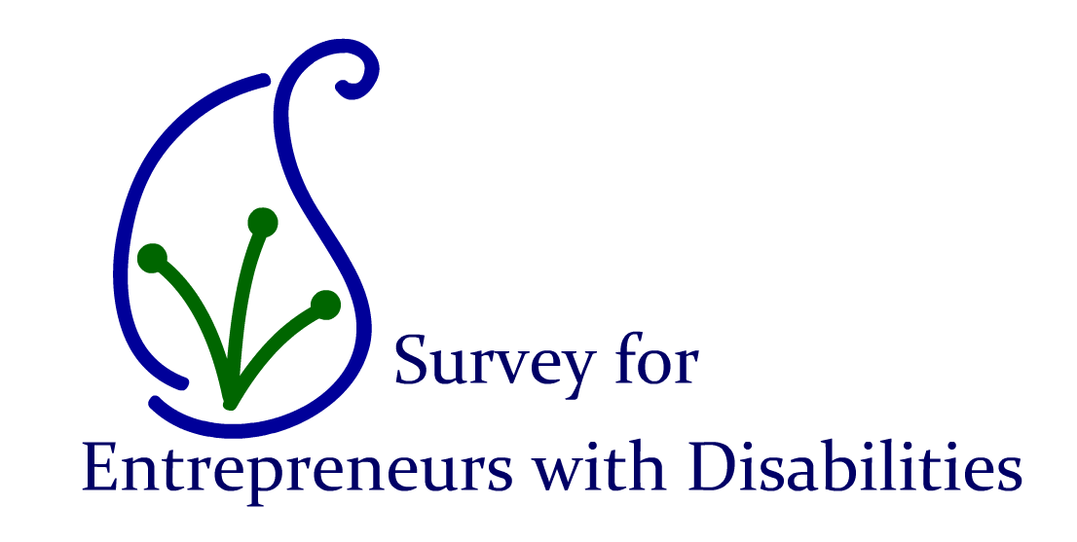

DIT, in conjunction with [disABILITY.ie](http://www.disability.ie/displaydoc.asp?a=gohome), is undertaking research examining people with disabilities in self-employment.

The objective of this survey is to gather information on the self-employment experience of persons with disabilities, including the motivations, benefits and barriers to self-employment. This is a critical study because research of this nature has never previously been conducted in the Irish employment context. In surveying established and aspiring entrepreneurs this research will gain greater insight to the nature of self-employment for people with disabilities, which not only has wider policy implications but can also assist in the development of business training programmes designed specifically for persons with disabilities.

If you are an established or aspiring entrepreneur with a disability we would be delighted if you would take the time to participate in this study. The Survey is available at the following link: <http://www.surveymonkey.com/s/3S7J5M6>

If you have any queries or questions regarding this research please don’t hesitate to contact Jennifer Manning ([jennifer.manning@dit.ie](mailto:jennifer.manning@dit.ie)) or Dr Thomas Cooney ([thomas.cooney@dit.ie](mailto:thomas.cooney@dit.ie)) in Dublin Institute of Technology.